FAN YEAR IN REVIEW
FY 2021-2022

The FAN fiscal year kicked off June 1, 2021 with optimism after a year of restrictions due to the COVID-19 Pandemic. The first order of business was two-fold: secure a venue for face-to-face General Meetings starting in September and get activity groups back up and running.

The Executive Board voted in by the general members:

Position: | Filled by:
President | Kathleen Court
1st VP – Programs | Sherry Dunn
2nd VP – Membership | Claudia Gallagher
Secretary | Sandi West
Treasurer | Debi Swaney
Auditor | June McMillin
Newsletter Editor | Kim Gerrish
Historian | Lin Fish

Those accepting Extended Board positions:

Position: | Filled by:
Activities Chairperson | Margaret Farhadi
Holiday Luncheon Chairperson | Carol Huddleston
Cookie Exchange Chairperson | Helen Moorman
Daytime (Bus) Trips | Noemi Sirisaengtaksin
Directory Chairperson | Sandy Darst
Greeters | Marianne Steinbacher
Spring Luncheon Chairperson | Diane Webb
Publicity Chairperson  (includes Directory Ad Sales) | Colleen Bradford
Socials Chairperson | Jacquie Stamates
Sunshine Chairperson | Shelley Gross
Web Manager | Laurie Nimberger
Charity Chairperson | Linda Comeaux

Extended Board Positions from the previous year that the President chose not to fill at the beginning of this year were:
- Fundraising Chairperson – due to charity fundraising activities being part of the Holiday Charity Luncheon (as was the case prior to the COVID-19 restrictions on public gatherings)
- Overnight Trips Chairperson – due to small number of participants in prior years and uncertainty of when attractions would re-open post COVID-19

In December, the club Secretary resigned due to health issues. Sandy Darst agreed to fill the position on an interim basis until the end of the fiscal year.

The President’s focus areas for this year were:
- Maximize opportunities for getting together through Activity Groups, Socials, Daytime Bus Trips, and Houston Excursions
- Continue efforts to grow FAN membership by creating more awareness of our organization in the community through word of mouth, an improved public website, and social media.

In January, per FAN bylaws, the nominating committee was selected for preparing a slate of Executive Board candidates to be elected for the following year. Committee approved by the board were:

Chair Jennifer Banks, Immediate Past President
Kim Gerrish and June McMillin, board members
Margaret Burgess, Lena Habiby and Brenda Van Derbur, members
Carolyn Grimes and Sharlene Nelson, alternates

The candidate slate was shared at the April General Meeting and voted on by show of hands.

A major initiative undertaken by the President this year was the update of Executive and Extended Board job descriptions. Executive Board job descriptions have been updated, reviewed by the Executive Board members and are ready for upload to the FAN website. The purpose of the update was for the President and new incumbents to have better understanding of job responsibilities and job complexities. The Extended Board job descriptions are in the process of being updated and will be reviewed next year.

General Meetings

The 1st VP – Programs’ search for a General Meeting venue was difficult due to availability, budget limitations and the uncertainties of opening facilities to the public post-COVID. The following options were presented to the Executive Board for consideration.
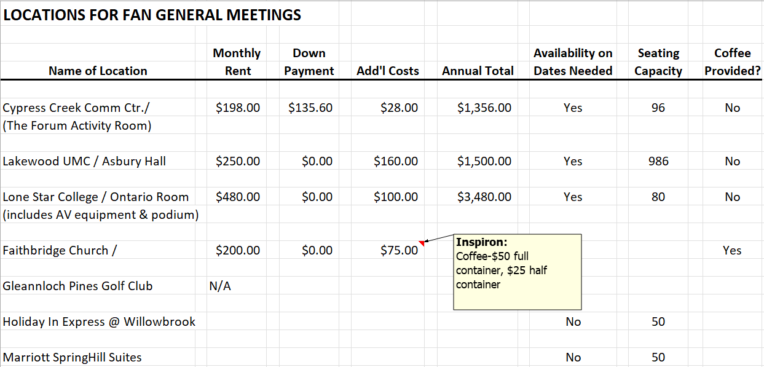

Cypress Creek Community Center is a little small for our needs, Lakewood UMC is larger than we need but they were willing to meet our budget, Lone Star College is too small and above our budget. At the last minute we were able to negotiate a contract with Faithbridge at the same rate as in 2019-2020 (shown above). This venue is a good location for FAN members and is a great facility for the General Meetings. (See Attachment I – Faithbridge Contract)

The General Meeting programs arranged by the 1st VP – Programs were as follows:

Month | Program | Attendance
September 7 | The Woodlands Show Chorus | 81
October 5 | Medicare 101 – Simplifying a Confusing Topic | 72
November 2 | Accessorizing with a Splash of Sass | 94
January 11 | How to Make Money Last – New Tax Laws for 2022 | 48
February 1 | My Yard Is a Mess, Now What? | 80
March 1 | The History of the Pearl Fincher Museum of Fine Arts and the Student Art Contest | 79
April 5 | The Texas Master Chorale | 88

On average, 35% of members attend the General Meetings. Three or four guests chose to join FAN at each of our monthly meetings. January attendance was low, but that is typical. No definite correlation can be drawn between program topic and attendance numbers. A special member appreciation program and treat was provided at the April 5 meeting. In addition to the entertainment, cupcakes were brought in for all to enjoy.

Membership

Fan’s primary source of revenue to cover expenses, except the Membership Directory, is membership dues. The membership goal was set at 250 to meet expected expenses. FAN ended the fiscal year with 261 members.

Due to slow renewals and the desire to have as many members as possible listed in the Membership Directory, the Executive Board approved extending the deadline for paying dues to September 7. Membership numbers increased by 24 from July to September; however, the extension did not garner as many additional members included in the directory as expected.

Analysis of membership numbers showed that nearly 25% of our members were new and all joined FAN due to invitations from current FAN members to check us out. It is believed that most join FAN to participate in the wide variety of activities available to members.

To have new member contact information available to the membership at large, the Membership VP provides new member contact information to the Newsletter Editor. She adds this information as an attachment to email distributed to all members when a new FANfare is published. Members can add this information to the current membership directory. Previously this information was published in the newsletter; but due to the public nature of the newsletter, it was decided that this information should be made available to the FAN membership only.

Finance

At the September 7 General Meeting, a balanced budget was presented to the general membership for approval. Approval was granted. At year end, Income was $878 higher than forecast primarily due to directory ad sales and Expenses were $400 lower than expected. (See Attachment II for year-end budget report)

During the meeting with our bank representative to update account signature requirements, the Treasurer and President brought up the subject of FAN using Zelle to accept payments from members for dues, event reservations, bus trip costs, etc. While it is very simple to set up Zelle, it became apparent that monitoring the bank account to identifying who is paying for what would be a very tedious and time-consuming job. In addition, with every payment received from a FAN member there is an accompanying form which the member completes, and FAN strives to maintain a two-person sign off for funds received. There would be no leverage to have the forms completed and the two-person sign off would be compromised. It was decided to not undertake this initiative.

Later in the year, the lack of a means to make digital payments to FAN was brought up by a member during the membership renewal campaign. The board agreed that the President would assemble a three-to-four-person team to determine what the club would need to do to implement this option, detailing what process changes would be needed, and make a recommendation. While attempting to assemble the team, it became apparent that there was no support from the board to pursue this, primarily because of the issues with Zelle identified at the beginning of the year. The initiative was abandoned for the time being.

A situation arose where a member requested reimbursement of expenses incurred for a social event, but receipt was lost. The precedent set in the past was to deny reimbursement. After consulting with the President, Advisor and past Treasurers, the Treasurer was given approval to make the reimbursement. On a go-forward basis, it was decided that this situation would be handled on a case-by-case basis and, with event chairperson validation that expenses are valid and President’s approval, reimbursement will be made.

Audit

The monthly audits were conducted as specified in FAN’s bylaws. The end of year audit was completed with no abnormalities found. (See Attachment III)

Newsletter

The FAN newsletter, FANfare, is published each month, except June and July are a combined issue. FANfare is available on the FAN website and members are sent a link to the newsletter on the website when a new issue is published. Members have an option to request that a paper copy of the newsletter be sent to them via USPS. In addition to the postage cost, there is also the cost of printing. The Newsletter Editor and the 2nd VP – Membership made a concerted effort to reduce the number of newsletters needing mailing to members via USPS. The year ended with 14 members requiring mailed paper copies.

A reminder email is sent to the Executive Board, Extended Board and Activity Group Leads on Monday prior to the article submission deadline. The article submission deadline is the Friday prior to the Board Meeting. A draft of the monthly FANfare is presented to the Board during the monthly Board Meeting for review. The monthly FANfare is published to the FAN website and members are sent the email link, including any membership additions and changes, or mailed paper copies by the Sunday following the Board Meeting.

The Newsletter Editor is the custodian of FAN’s Office Depot discount card, due to this position being the primary user. The discount card is valid for printing and purchases. The account number is available to board members to use in conjunction with club business.

Activities

Activities are considered to be the life blood of FAN, therefore there was considerable effort put into supporting Activity Group Leaders to revitalize the groups after COVID, replace Activity Group Leaders where needed, and add new groups as requested by the members. Nearly all activity groups did not meet for nearly a year during the COVID shutdown and many group leaders were reluctant to resume meetings indoors or at restaurants.

The Activities Chairperson enhanced and expanded the activities sign-up tables at the General Meetings and worked closely with the Activity Group Leaders to support their needs. New activities added in this fiscal year included Mexican Train, Houston Excursions, Dirt Divas (garden club), Tech Tutors, National Mah Jongg, and Happy Hour. By offering Wright Patterson and National Mah Jongg classes, these groups have been able to expand. The Railroad Canasta group has grown significantly. Participation in Bridge seems to have declined, but there is a training class in session. The Line Dancing Group has had difficulty finding a venue that meets their needs.

Holiday Charity Luncheon

The annual Holiday Charity Luncheon was held at Northgate Country Club on December 7. See ATTACHMENT IV(a) – Silver Bells Charity Luncheon for program and ATTACHMENT IV(b) for list of Business Contributors to Silent Auction and Raffle. Ticket prices were $45 which included a $5 donation to FAN’s selected charity, Living Legacy. 140 members attended and two new members joined.

The theme of the event was Silver Bells; the entertainment featured a fashion show directed by FAN members and supporters D’Ann Gummelt and Sheri Kendrick of Splash of Sass. The charity fundraising activities included a wine pull, raffle ticket sales, silent auction, and donation box. Over $6,700 was raised for Living Legacy at the Holiday Charity Luncheon. $1,255 was raised from raffle ticket sales at the FAN Spring Luncheon and earmarked for donation to Living Legacy. Total contribution, including donations that were paid directly to Living Legacy, was $8,000.

Over the past several years, FAN has discussed the possibility of accepting credit cards for purchase of silent auction items. Due to the expense of obtaining a card reader and the fee paid to credit card companies for each purchase, FAN has not pursued this option. This year, Living Legacy agreed to having one of their staff at the luncheon to accept credit card sales using their card reader. This was thought to have a positive impact on funds raised (credit card charges were nearly $1,000).

Cookie Exchange

This is a long-standing tradition at FAN. It is held on the second Wednesday in December at the Spring Creek Oaks Clubhouse. The event includes lunch, holiday-themed party games, and an exchange of home baked cookies brought by members attending. The cost to attend is set to cover all associated expenses, i.e., this event is cost neutral to FAN. This year the cost per attendee was $16. Twenty-five members attended “Ye Ole Fashioned Cookie Exchange”. A box lunch was brought in from Chicken Salad Chick. Many of the attendees volunteered to lead a game and contributed the prize.

Daytime Bus Trips

These bus trips utilize the free Harris County Precinct buses for daytime trips in the vicinity of Houston. Only trained coordinators can reserve the buses. Fan usually plans a bus trip for the fall and the spring.

The fall trip was to the Painted Churches in Schulenberg on October 8. The group visited four churches, with guided tour at two (cost $15), and enjoyed lunch at Sengelmann Hall (cost $14.50).

The spring trip was a tour of the Round Top Festival Institute on March 11 (cost $10). The 90-minute guided tour included the 1,000 seat Festival Concert Hall, the David W. Guion and Anders and Josephine Oxehufwud Museum Rooms, the Edyth Bates Old Chapel with an 1835 Henry Erben organ and an 1863 Traugott Wandke organ, and the Menke House parlors. The day trippers could have lunch at Royer’s or a restaurant of their choice in the area. Twenty-two members participated in this trip; there were some cancellations due to inclement (cold, rainy, windy) weather.

Directory

The membership directory includes contact information for FAN members who pay their membership dues by the designated date and who wish to be included. In addition there is important information about the club’s board, general meetings, board meetings, events, activity groups, and bylaws.

The directory is financed by ads sold to local businesses who value FAN’s patronage. The 2021-2022 directory included 21 ads.

The Directory Chairperson was not directly responsible for the ad sales; ad sales were delegated to the Publicity Chairperson this year. This led to confusion and communication issues among the Directory Chair, Publicity Chair and the printer. It was recommended that the Directory Chair be in charge of all aspects of the directory compilation and publication, including ad sales next year.

The members were invited to submit photos and artwork for the directory cover. Selection was made by the Directory Chair.

The directory was printed by Krailo Printing. This year’s directory included only a “preferred phone number” for each member. It was intended that the phone number would be identified as “C” for cell or “H” for home. Somehow this column of information in the membership data worksheet was not included in the directory. This oversight was communicated to the general membership, noting that the critical issue is that all numbers are not cell phone numbers which are needed for texting. Members were encourage to check with their Activity Group Leaders to make sure their contact information was correct.

Publicity

While many possibilities and opportunities were discussed for advertising FAN, all discussions concluded that nearly all of our new members come from current members inviting their friends, neighbors and new acquaintances to attend a meeting or activity session. Advertising in subdivision newsletters usually requires that the notification come from a resident. While there is some posting on nextdoor.com, membership application forms do not indicate that this is a significant source of new members. By the end of the year, it was decided that this position should to be re-evaluated and possibly eliminated from the Extended Board.

Sunshine

A card is sent on behalf of FAN in the event of a member’s or family member’s illness or death. A major concern for the Sunshine Chair is privacy and consistency. Some members do not want their “life event” publicized. To respect the wishes of our members, the Sunshine Chair contacts the member (or family member), when notified of a life event, to know whether or not she wants this information included in the club newsletter and posted on our social media page. The board voted to not post death notices on the club’s social media page.

The club policy was to make a donation of $25 to charity in the member’s name in the event of an active member’s death. Because it may be months later that we hear this news and this policy has not been consistently applied in the past, the board agreed that this policy be discontinued.

In the event of a current board member’s death, the Sunshine policy allows for a $25 donation to be made to the family’s charity of choice or to the club’s selected charity.

The board agreed that, if requested by the member or family, blast emails can be sent to all members inviting them to attend the funeral or memorial service of a member or family member when the newsletter is not a timely vehicle for this communication. The Sunshine Chair forwards the details of the service to the board member designated to send blast emails.

Greeters

This job provides hostesses to greet and welcome people attending General Meetings and events. This year the Greeters Chairperson collaborated with the Membership VP to host a New Member Welcome Brunch held at her home. 20 new members and 12 board members attended. Food was provided by the hostess and the board members. In addition to a buffet style brunch, ice breaker party games were played. This was not a budgeted event. The board voted to provide up to $250 for paper goods, decorations, and maid services to support the event. The event was very well received by the new members and will be proposed for inclusion in the budget for the following year.

Charity

The purpose of this job is to facilitate the selection of a charity for FAN to support the following year. This includes researching local charities, preferably small local charities that support women and/or children, selecting as many as six that would be of interest to the FAN general membership. These charities are presented to the board for consideration and the board selects by popular vote three. At the April general meeting, the three charities are presented to the general membership and a vote is taken to select the charity that FAN will work to support next year.

The Charity Chairperson cultivates a relationship with the Charity, seeks opportunities for FAN membership to learn about the charity, invites and hosts charity representatives to attend FAN events as appropriate.

This year’s charity selected by FAN membership was Living Legacy. A donor provides local honey which was offered for sale at FAN’s October General Meeting. FAN members were encouraged to shop at Living Legacy’s weekend farmer’s market and purchase honey. Living Legacy agreed to have their “Square” device available at the Holiday Charity Luncheon to accept credit card sales for silent auction purchases.

In February the Charity Chair presented the following six charities for the board to consider for support next year (2022-2023):

- Moving Water-Houston
- Inspiring Hands
- Shield Bearer
- Abandoned Animal Rescue
- Bridging for Tomorrow
- Loving Choice Pregnancy Center

By popular vote, Moving Water-Houston, Shield Bearer and Bridging for Tomorrow were selected for presentation to the general membership for next year’s charity. Shield Bearer received the most votes at the April General Meeting.

Socials

Social events are the only opportunity for members in include their spouses/partners in the event. There is typically a fall and spring event planned for a dinner at an upscale local restaurant.

This year, FAN hosted an evening at the Sam Houston Raceway on April 9, which was the last night for thoroughbred racing. In the tradition of the Kentucky Derby, there was a Derby hat contest for most original and funniest. The winners were Shelley Gross and Carolyn Grimes. The event was well attended and feedback from members attending was very positive.

Spring Luncheon

The Spring Luncheon, titled Spring Fling, was held on May 3 at Shirley Acres. See ATTACHMENT V for event program. The cost per attendee was $45. A presentation was made to Living Legacy recognizing the fact that FAN raised $8,000 for them during the year. See Charity section for details on funds raised.

The Nominating Committee Chair led the installation “ceremony” of the Executive Board for the year 2022-2023. All current board members received a “Thank You Bunches” gift and board members not returning for another term were given special recognition.

Website and Social Media

A new FAN website was created this year, using WIX as the platform. It is connected to Google which favors FAN popping up in searches for women’s groups, it has a public section that anyone can look at to learn about FAN and private section where club business documents can be stored with restricted access. FAN was able to purchase a three-year contract during a 50% off sale. Invoices and Terms of Use can be found on the website. The new website was officially launched in January with announcement and demonstration at the January 11 General Meeting.

FAN’s historical documents, including meeting minutes and newsletters, were moved from the old website to the new website. The old website was decommissioned in February.

This year the Website Manager also took on responsibilities for maintaining the club’s presence on Facebook.

ATTACHMENT I – Contract with Faithbridge for FAN General Meetings, September 2021 – April 2022 (Page 1 of 2)

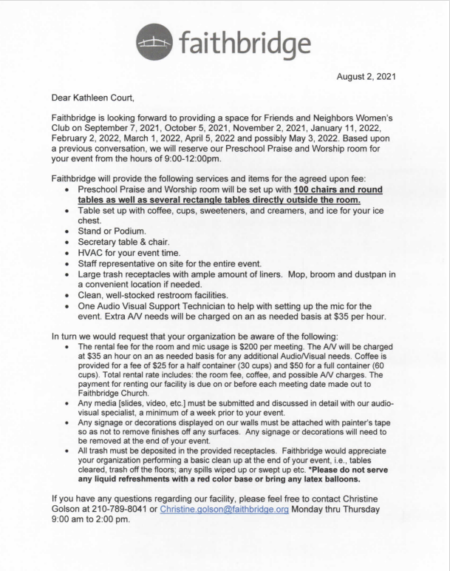

ATTACHMENT I – Contract with Faithbridge for FAN General Meetings, September 2021 – April 2022 (Page 2 of 2)

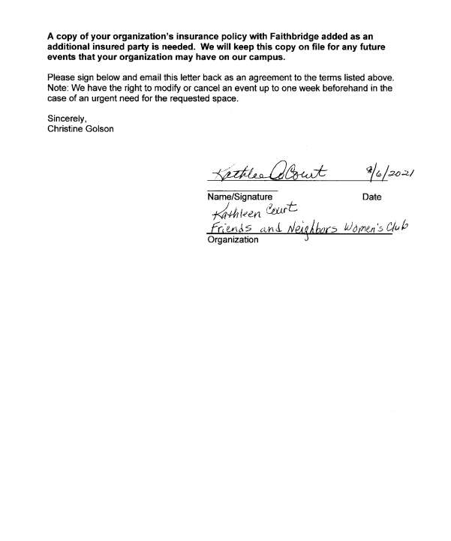

ATTACHMENT II – 2021-2022 Annual Budget (end of year report)

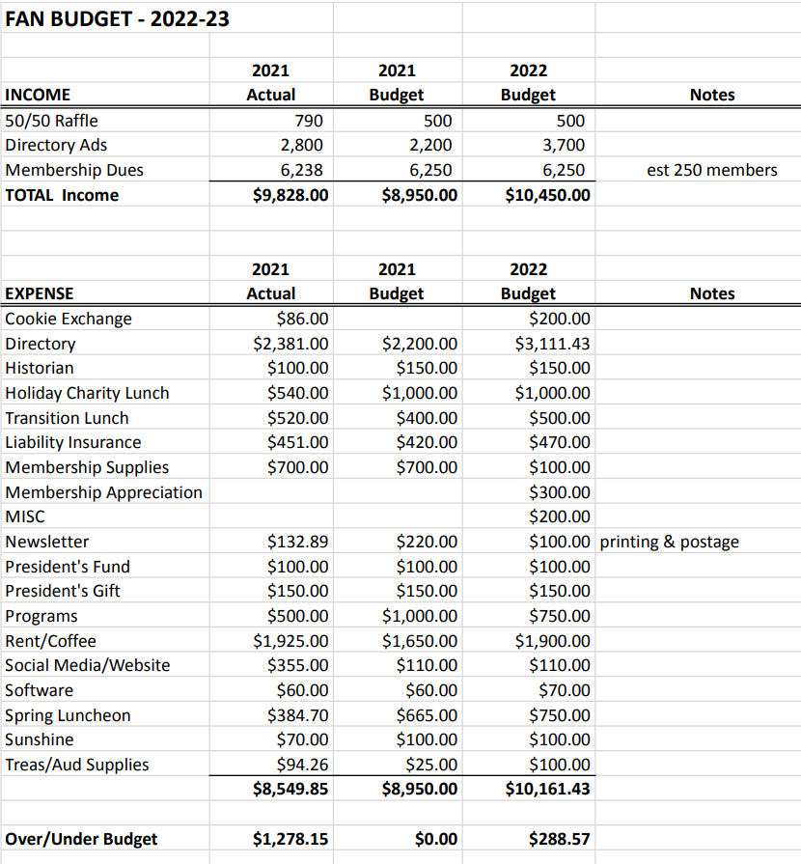
ATTACHMENT III – 2021-2022 Annual Audit Report

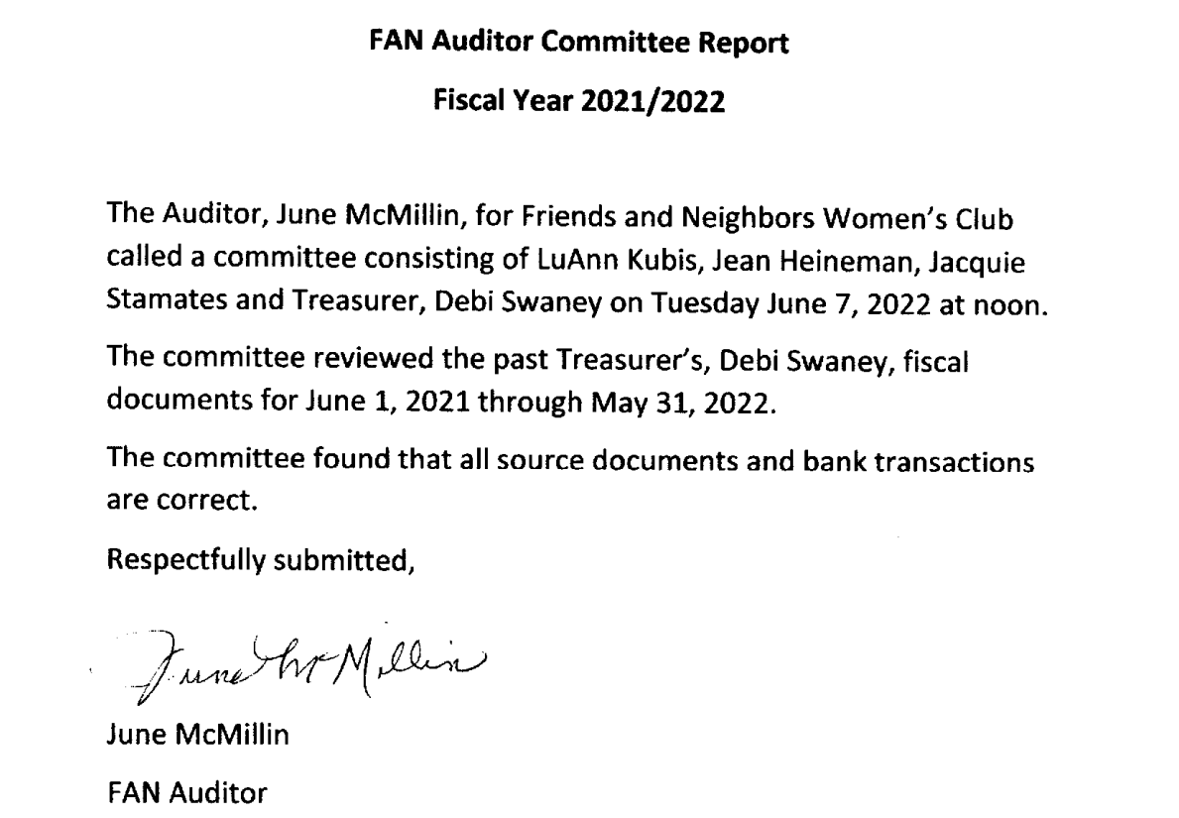

ATTACHMENT IV(a) – Silver Bells Charity Luncheon Program

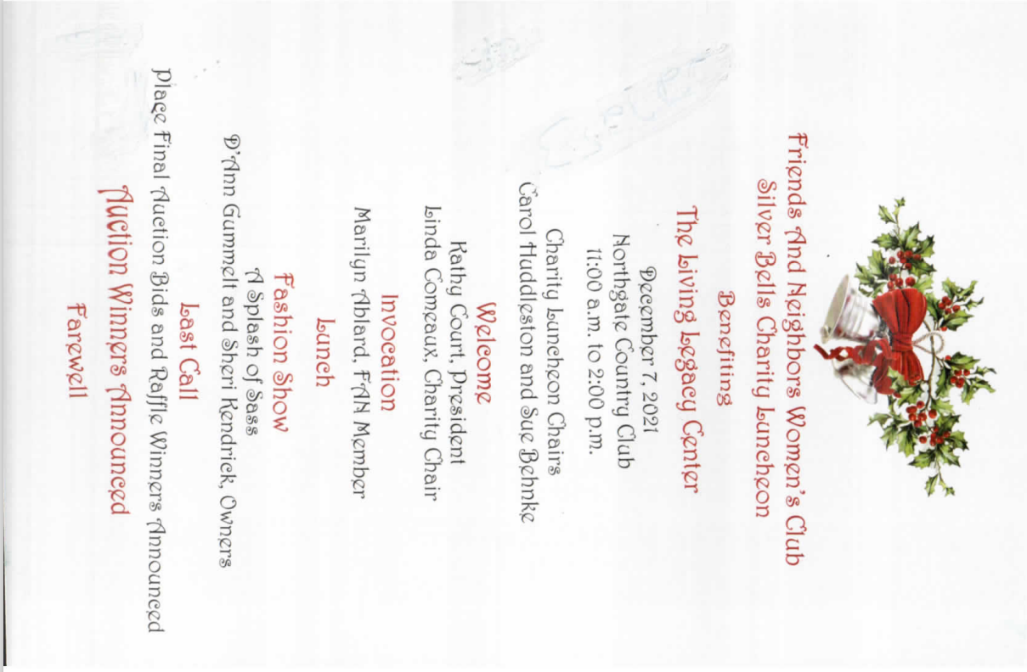

ATTACHMENT IV(b) – Silver Bells Charity Luncheon – Business Contributors

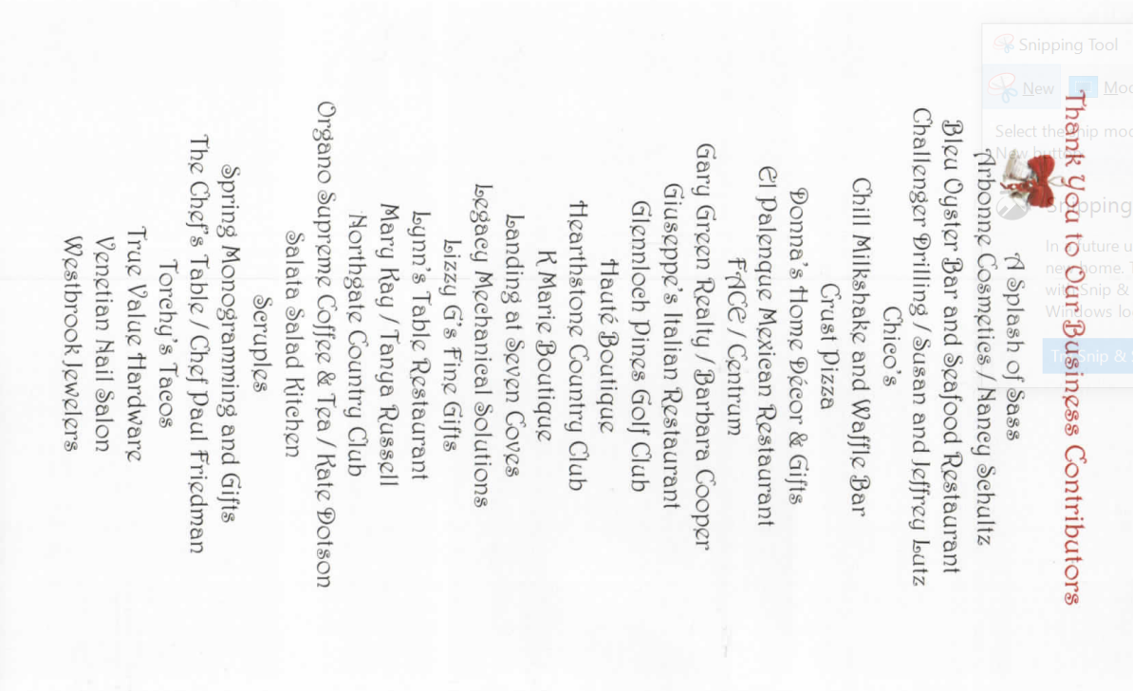

ATTACHMENT V – Spring Luncheon Program

